**Project Design Phase-II**

**Technology Stack (Architecture & Stack)**

|  |  |
| --- | --- |
| Date | 04 November 2022 |
| Team ID | PNT2022TMID06107 |
| Project Name | Personal Assistance For Seniors Who Are Self-Reliant |
| Maximum Marks | 4 Marks |

**Technical Architecture:**

The Deliverable shall include the architectural diagram as below and the information as per the table1 & table 2

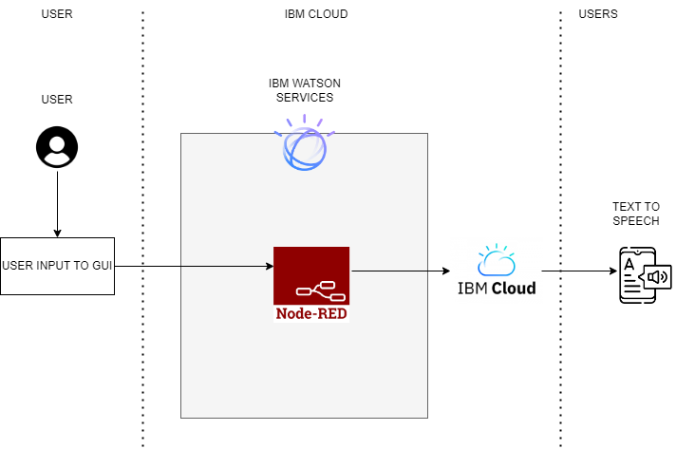

**Table-1 : Components & Technologies:**

|  |  |  |  |
| --- | --- | --- | --- |
| **S.No** | **Component** | **Description** | **Technology** |
|  | User Interface | Mobile App | HTML, CSS, JavaScript |
|  | Application Logic-1 | Receive data from node-red by using IBM Watson IoT platform | Python |
|  | Application Logic-2 | Get the time and compare it with the time stored in the database. Send the medicine time to IBM IoT platform at the desired time | NODE-red |
|  | Application Logic-3 | Reminder | IBM Watson Device |
|  | Cloud Database | Desired time and medicine details will be stored in the IBM Cloudant DB | IBM Cloudant |
|  | External API-1 | It notifies the care taker with the medicine name. | Text to Speech API |
|  | Infrastructure (Server / Cloud) | It stores the medicine and time details | Cloud Foundry |

**Table-2: Application Characteristics:**

| **S.No** | **Characteristics** | **Description** | **Technology** |
| --- | --- | --- | --- |
|  | Open-Source Frameworks | open-source frameworks used in IBM Watson | Technology of Opensource framework IBM Watson |
|  | Security Implementations | IBM Cloud | Watson Assistant has certifications such as ISO,SOC2,US HIPPA,European Union GDPR,PCI DSS.  We use security systems such as TCS/SSL,IPSEC,Third party CAs,HTTPS,Encrypted file system,Encrypted storage systems,key management systems,AES -256 bit |
|  | Scalable Architecture | Web interface architecture consist of four pillars. They are intents, entities ,data flow, scripts (3 – tier architecture Micro-services architecture) | Technology used IBM Watson Assistant |
|  | Availability | The Web interface is made available using load balancers, distributed servers etc. | Technology used BM Watson Assistant |
|  | Performance | IBM Watson –automate processes | Technology used BM Watson |

**References:**

[**https://c4model.com/**](https://c4model.com/)

[**https://www.ibm.com/cloud/architecture**](https://www.ibm.com/cloud/architecture)

[**https://aws.amazon.com/architecture**](https://aws.amazon.com/architecture)

[**https://medium.com/the-internal-startup/how-to-draw-useful-technical-architecture-diagrams-2d20c9fda90d**](https://medium.com/the-internal-startup/how-to-draw-useful-technical-architecture-diagrams-2d20c9fda90d)